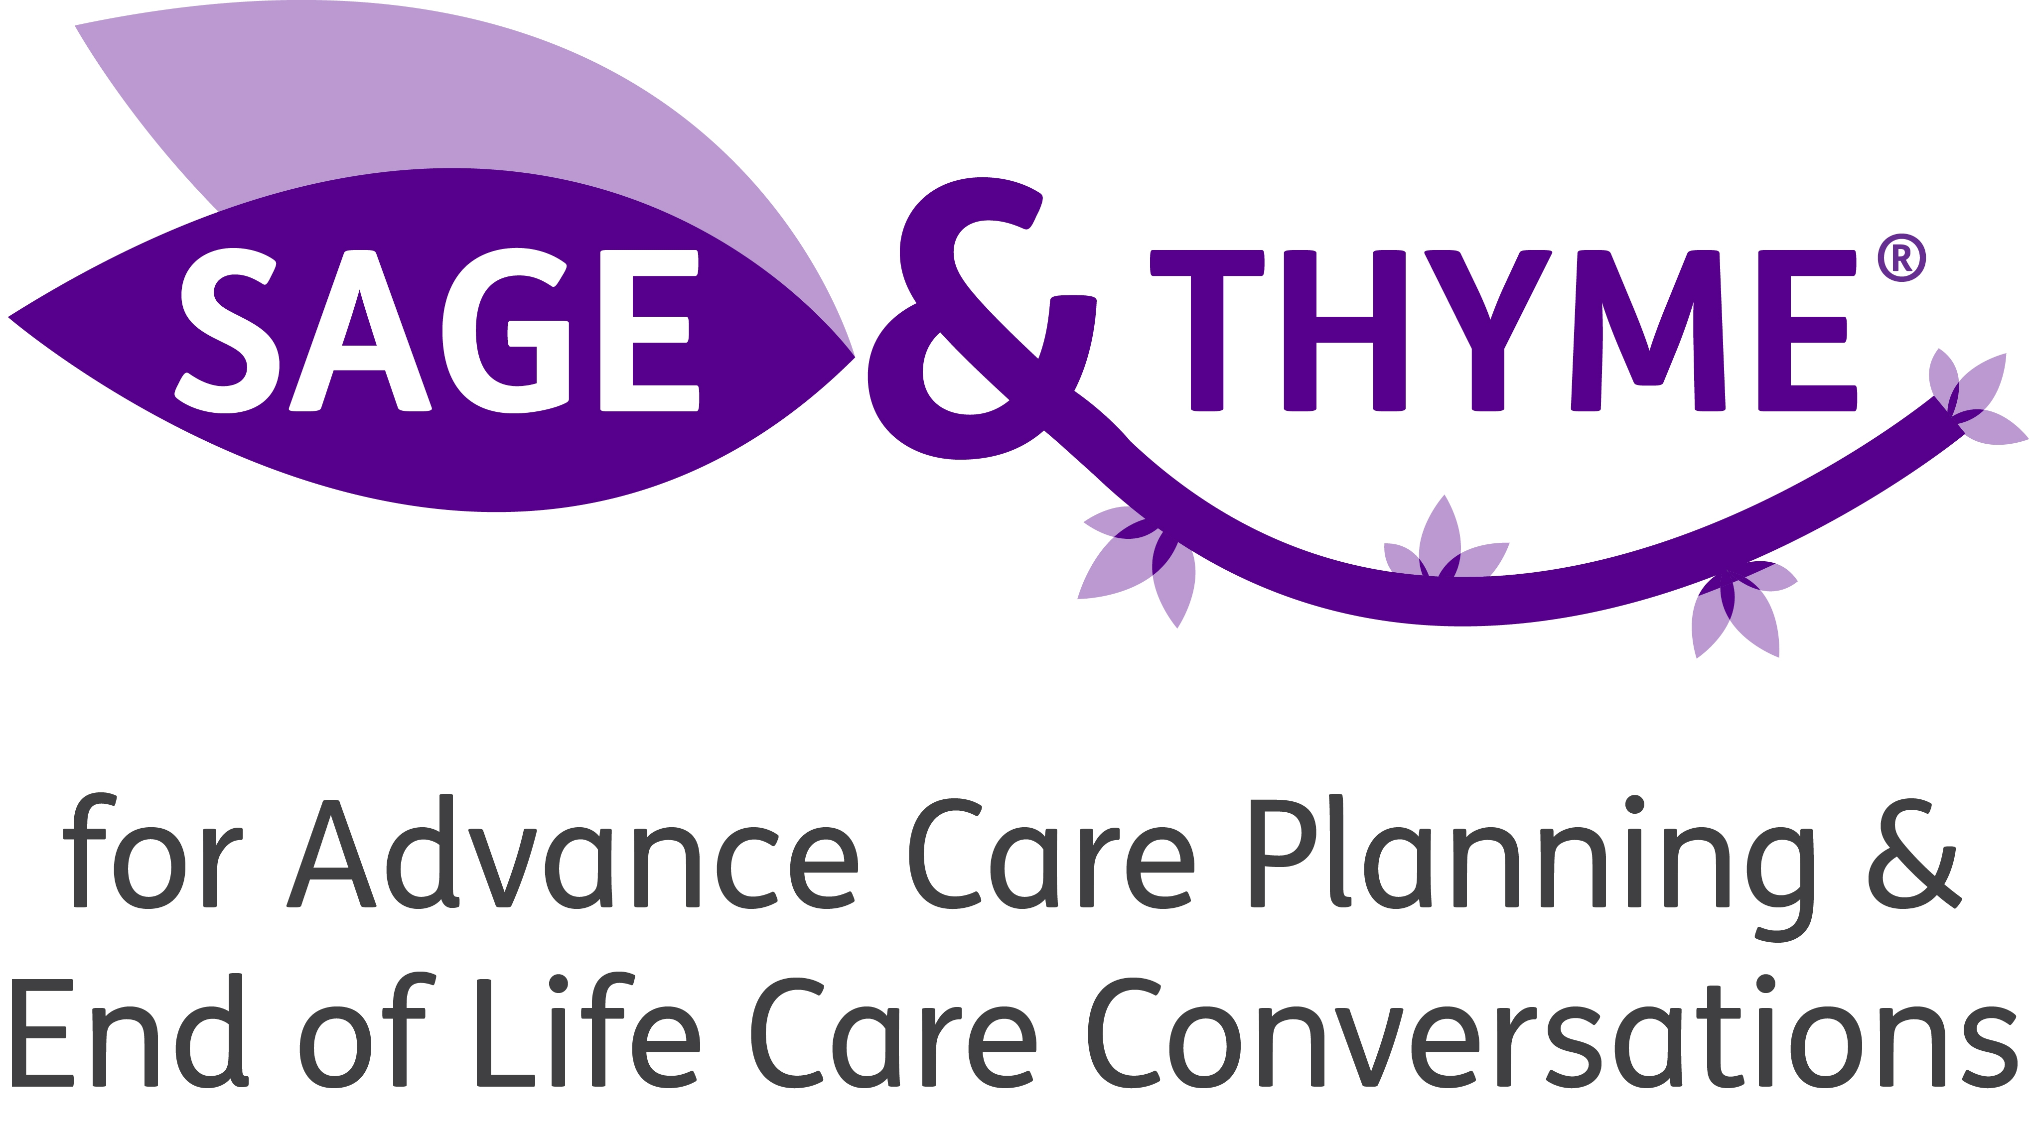

Introduction
18 March 2014

- Background – SAGE & THYME Foundation Level Workshop

The SAGE & THYME® model is a structured and evidence-based approach to dealing with someone in distress. It was developed by University Hospital of South Manchester NHS Foundation Trust (UHSM) and a patient in 2006 in response to NICE guidance. It is delivered in a 3 hour workshop (‘SAGE & THYME foundation level workshop’) for up to 30 learners, using 3 facilitators. Its aim is to teach the foundation level skills of dealing with people in distress such that the learners can:

- Recognise psychological distress
- Avoid causing psychological harm
- Communicate honestly and compassionately
- Know when they have reached the boundary of their competence.

During the workshop learners are reminded how to listen and respond in a helpful way to empower the person who is upset/worried, and also how to get into and out of the conversation, in an appropriate manner. The workshop uses a combination of a lecture, small group work and interactive rehearsals of the conversation.

Research with 412 learners has shown that the SAGE & THYME foundation level workshops had a significant positive effect on self-confidence (p <0.0005), self-perception of competence (p < 0.0005) and willingness to explore the emotional concerns of patients (p < 0.0005). In addition, 95% felt that the workshop would be very likely to have an impact on their practice.

Demand from other organisations such as NHS Trusts, universities and hospices to run the workshops has been high, so in 2010, UHSM established a commercialisation programme and now trains others to become SAGE & THYME facilitators and licences their organisations to deliver SAGE & THYME foundation level workshops.

The workshop is suitable for all health or social care staff wishing to learn or enhance foundation level communication skills across all settings (including non-clinical areas) and disease groups.

- SAGE & THYME® for Advance Care Planning (ACP) and End of Life Conversations Workshop (‘SAGE & THYME ACP’)

This workshop is based on the SAGE & THYME model. It was developed in 2011 by staff working for Lancashire and South Cumbria Cancer Services Network (LSCCN). At the time, LSCCN offered SAGE & THYME foundation level workshops across the locality, to all health and social care staff in all care settings. Requests were being made for the workshop to focus on advance care planning for GPs. As the skills and structure of the SAGE & THYME model are transferable, the foundation level workshop was adapted to focus on the particularly challenging consultations that address advance care planning (ACP) and end of life issues.

The SAGE & THYME ACP workshop lasts for 3.5 hours, is run by 3 facilitators, and can be attended by up to 30 participants. It uses a combination of a lecture, small group work and interactive rehearsals of the conversation.

During the workshop learners focus on effective communication skills that help open an advance care planning conversation. The structure provides a consultation guide as concerns and issues are disclosed.

Note that the workshop does NOT cover: breaking bad news; Mental Capacity Act; or specific documents such as ‘preferred priorities of care’.

The SAGE & THYME ACP workshop has been delivered to a number of GPs, community nurses, acute and out-of-hours staff who are responsible for advance care planning. The participants’ feedback has demonstrated that they have an increased confidence in starting an end of life care or advance care planning conversation, and in responding to a patient’s or relative’s concerns during the conversation. They also rate their competence in conducting such a conversation more highly after the workshop.

UHSM now runs SAGE & THYME ACP workshops for organisations on a commercial basis.

The workshop is suitable for senior staff who would engage in advance care planning/end of life care discussions with patients and relatives in the course of their role (working at level 2 of the four level NICE communication model¹).

This is a new course and therefore the ACP SATFAC course, branding and licence fee are still in development.

- Summary of similarities and differences between SAGE & THYME Foundation Level and Advance Care Planning workshops

 | SAGE & THYME Foundation Level | SAGE & THYME ACP
Target audience | All levels of health and social care staff (clinical and non-clinical) requiring foundation level communication skills | Senior staff who engage in advance care planning/end of life care conversations (e.g. GPs, healthcare staff, social workers, lawyers)
Previous experience required | None | Experience of advance care planning / end of life care/ Gold Standards Framework
Aims | To provide a structured approach to dealing with concerns | To provide a structured approach to addressing advance care planning issues and dealing with concerns
Duration of workshop | 3 hours | 3.5 hours
Number of learners per workshop | 30 | 30
Workshop format | Lecture, small group work and interactive rehearsals | Lecture, small group work and  interactive rehearsals
Workshops delivered by | UHSM and other organisations with a licence to run the workshops | UHSM
- What do others say about the SAGE & THYME ACP workshop?

Dr Peter Nightingale, GP: “I was reasonably confident about communication in EoL [end of life] (perhaps cocky!), so when I attended the SAGE and THYME workshop last September I smugly thought I didn't have much to learn. I was wrong; it helped me greatly to structure conversations better. I used this structure for the Dying Matters DVD which was well received. The 30 GPs in Morecambe also gave very positive feedback.”
Dr Ayede Ejere, GP: “Excellent; very enlightening and educative. Will recommend this to other doctors."
Heart Failure Nurse: “A very informative and worthwhile workshop giving healthcare professionals insight into the importance of [a] structured model to help with ACP.”
Dr Melissa Robertson, GP: “An excellent, informative and constructive workshop that will definitely help me with those tricky conversations - 3 hours well spent!”
Dr A Rawson, GP: “Excellent. Should be mandatory.”
Dr Stephen Huck, GP: “This workshop gives a clear structure to help make difficult conversations much easier.”
Hospital doctor: “I now have a strategy for initiating difficult conversations and dealings with questions and concerns from patients that I may not have immediate solutions for.”

- Contact details

If you are interested in:

  - attending a SAGE & THYME ACP workshop at UHSM
  - would like UHSM to provide a quote for running a SAGE & THYME ACP workshop in your area

Please contact Joanne Thomas, SAGE & THYME team:
E: Joanne.thomas@cmft.nhs.uk
T: 0161 276 6965

NICE 2004: Improving Supportive and Palliative Care for Adults with Cancer.
Connolly M, Perryman J, McKenna Y, Orford J, Thomson L, Shuttleworth J, Cocksedge S. (2010). SAGE & THYME: A model for training health and social care professionals in patient-focussed support. Patient Education and Counseling; 79: 87-93.

