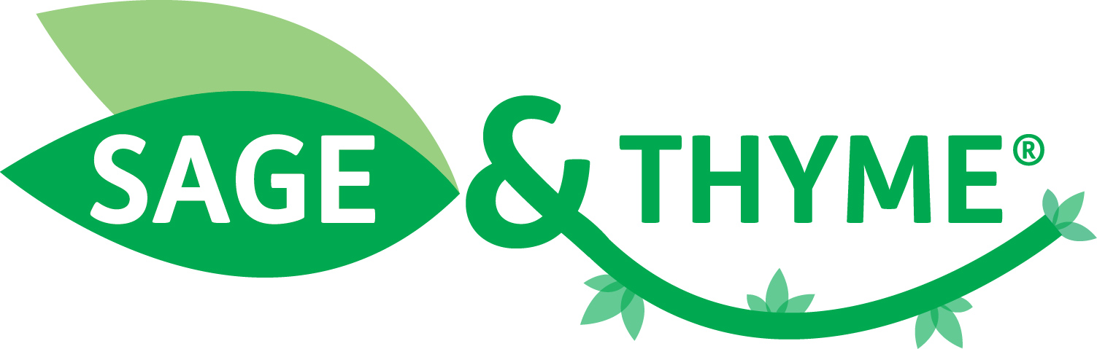

Summary of the independent evaluation of the SAGE & THYME foundation level workshop conducted by The University of Northampton Institute of Health and Wellbeing
18 May 2017

The SAGE & THYME foundation level workshop has been evaluated by The University of Northampton Institute of Health and Wellbeing, as one component in a series of multi-professional and multi-agency training courses run, to ensure the delivery of high quality services to frail and older people in Northampton.

The Northamptonshire Local Education and Training Council (LETC) received funding from Health Education England to run and evaluate a suite of training courses (including SAGE & THYME) centred around: prevention and enabling self-care; geriatric assessment and personalised care planning; management of long term conditions; and end of life care.

The SAGE & THYME foundation level workshop was delivered by the Northamptonshire Healthcare NHS Foundation Trust.

The training was evaluated using a combination of: an online questionnaire completed by attendees; an online questionnaire completed by managers; questions answered by training providers by email; and comments elicited from a focus group comprising of members of the Frail and Elderly Steering Group.

105 people attended the workshop from a mix of NHS Trusts, a hospice and a two care homes.

The University’s report highlighted that:

- The SAGE & THYME (S&T) workshop “engenders a sense that this was a well presented, easy to follow communication course which could be applied to practice easily”.

- SAGE & THYME training identified positive changes to practice which could be transferred not only to patients and carers but also to colleagues. Indeed, 8 out of 13 people (62%) who answered the question, said that their training had also benefitted their colleagues.

- 31 out of 35 people (89%) who answered the question said that the workshop would lead to them changing their practice or work-related behaviour.

- The SAGE & THYME workshop received overwhelmingly positive feedback from managers. All reported that staff had given positive feedback and most felt they had seen evidence of a change in practice. Recognition of anxious patients, employing listening skills and empowering patients in their care decisions as well as increased confidence are all cited as positive outcomes of attendance.

- 100% (n=35) of the participants would recommend the workshop to colleagues.

Quote from delegates attending the workshop included the following:

- “This course is short, well structured, user friendly and appropriate to mental health as well as other nursing/caring disciplines. We spend a lot of our time asking questions, formulating our responses etc. and this is a good communication tool that I have already put in to practice.”

- “I feel there is a lack of training in the NHS on how to manage the psychological aspects of patients' health and this training gave a useful, evidence-based, simple tool that can be applied in practice.”

- “Since doing the course I have been more confident in gathering information from a patient when in distress to find out what is really bothering them. It is not always the first issue they may express.”

- “Understanding more about effective communication will really help me in listening/talking to patients and their families who I come into contact with on a daily basis. I feel it will also help my relationships with other members of staff as this type of training relates very much to all areas of communication.”

- “I feel it has given me the basic skills to improve my communication with not only patients but relatives and staff.”

